**f. 46r**

¶ca*pitulum* •39•

**f. 46v**

S • brid*is* mady*n*/

¶

**f. 47r**

¶ca*pitulum* 40

**f. 47v**

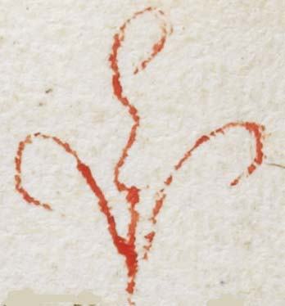

¶

¶

¶

**f. 48r**

n*ota* vanytee

¶ca*pitulum* •41•

ebrietas s*an*c*t*a •

¶

**f. 48v**

a ----

|

|

|

|

[

|

|

|

a-------

|

[

[ca*pitulum*] •42•

hem of her good*ys*

**f. 49r**

**f. 49v**

¶ca*pitulum* 43•

refresse

**f. 50r**

**f. 50v**

wostly

N

¶ca*pitulum* •44•

**f. 51r**

•h• husba*n*d

¶

at lyn*n* --------

**f. 51v**

no*ta* de colore]

N*ota*

so dyd p*ri*or Nort*on*

i*n* hys excesse

NO

<<< . . .

ih*esu* c*rist*

**f. 52r**

n*ota* [over blurred writing in orange]

**f. 52v**

amor •

i*n* pacie*n*s

¶

goyd mercha*n*d

¶ capitulum 45 •

**f. 53r**

dalyd

rych

___________

b

**f. 53v**

v• days

vii • day • fro

Brasto .;.

¶

**f. 54r**

¶capitulum •46•

n*ota*

v• tymes • Mare

v• tymes • Mare

¶

fire of

loue •

**f. 54v**

¶ca*pitulum* •47•

**f. 55r**

n*ota*

therin

n*ota*

**f. 55v**

preson

¶ca*pitulum* •48•

a deuout •

prayer

examinac*i*o

dura :~

**f. 56r**

xiiii child*ren*

¶

no*ta*

**f. 56v**

¶ ca*pitulum* •49•

¶

**f. 57r**

T Marcyall

N

**f. 57v**

¶

¶ ca*pitulum* •50•

¶

N*ota*

**f. 58r**

n*ota*

¶ca*pitulum* •51•

questio

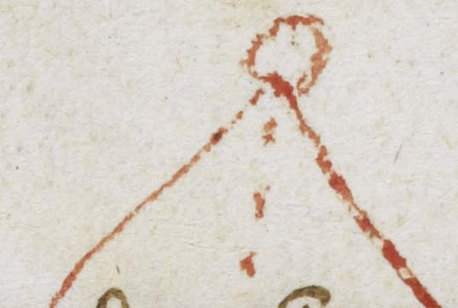

**f. 58v**

¶

**f. 59r**

n*ota*

seculer •p•

**f. 59v**

¶ ca*pitulum* 52 •

**f. 60r**

O ceci clerici

**f. 60v**

•:~---------

pappys

no*ta*

I use but comown